1. Select employee then go to their related action menu **Compensation** > Request **Compensation Change** to display the.

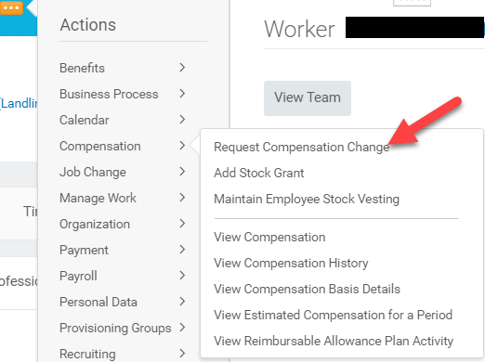

1. This will direct you to Request Compensation Change where you will fill in the Effective Date, Reason and Employee

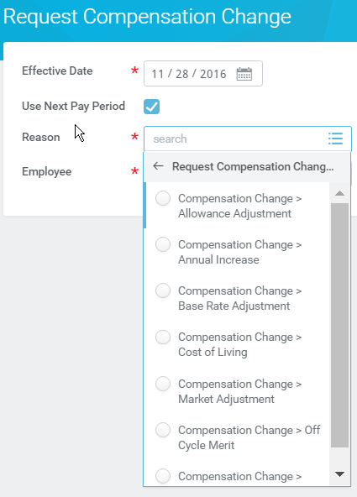

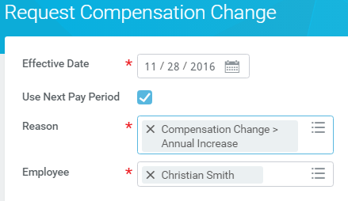

1. You will then want to make your changes. Note this employee is hourly so you can edit their hourly rate OR if they are moving to salary then you can ‘Add’ the salary option.\

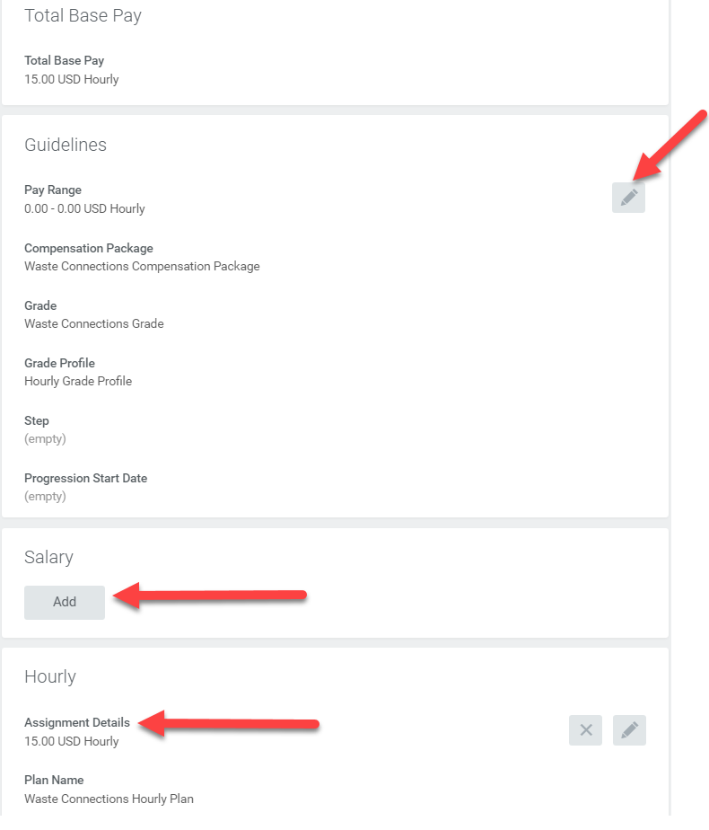

1. Then you can hit submit at the bottom 